Joichi/Jio Ito the founder of MIT Media Lab puts it clearly that *“The Blockchain is to trust as*

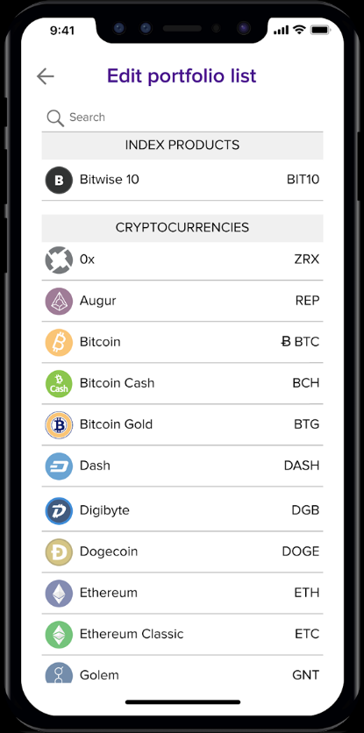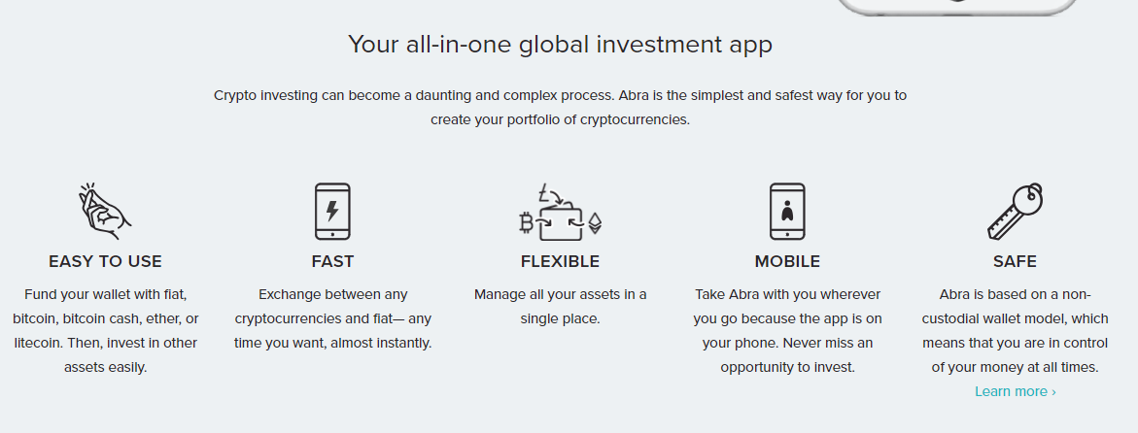**Bank and Payment:** Abra allows you to securely invest in 30 cryptocurrencies and 50 fiat currencies — all from one app. Fund your account and start investing by using bank transfer/wire, credit/debit card, or supported cryptocurrencies.

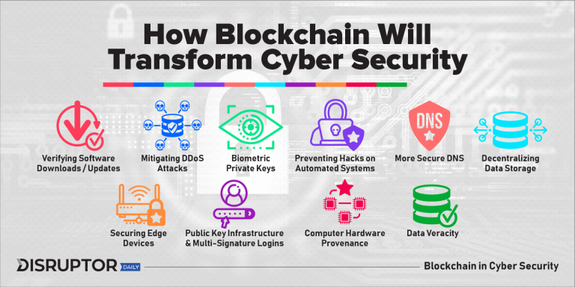

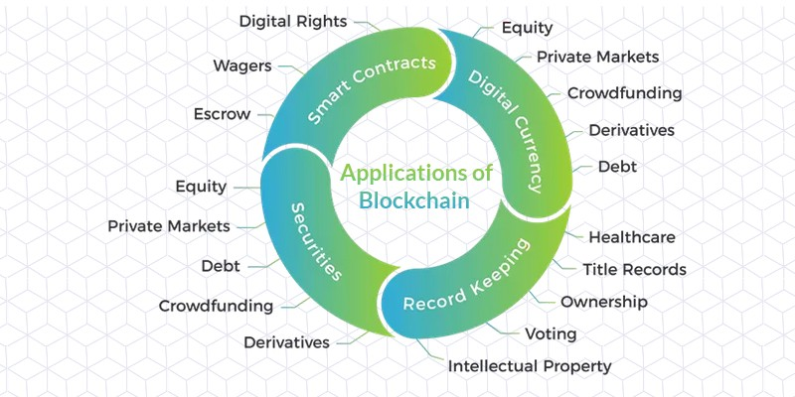

**Mitigating Denial-of-Service (DDoS) Attacks:** [**BlockArmor**](https://www.blockarmour.com/)**–**Leveraging blockchain technology to increase network size and make DDoS attacks more difficult

## Biometric Private Keys / Digital Identities to Replace Passwords

[**Civic**](https://www.civic.com/)**–**Identity solutions on the blockchain. Self-sovereign and digital identities

## Preventing Hacks on Automated Systems

[**Hacken**](https://hacken.io/?_ga=2.233465182.1967481977.1543175072-427108282.1543175072#security_excellence)**–** Token platform designed to incentivize the reduction of harmful attacks

## More Secure DNS

[**Ethereum Name Service**](https://ens.domains/)**–** Ethereum based DNS competitor

## Decentralizing Data Storage to Remove Honey Pots

[**Fluree**](https://flur.ee/)**–** Decentralized Database solutions for enhanced security and interoperability

## Securing Edge Devices via Identity Authentication

* [**Edge**](https://edge.app/)**–**Securing devices on the edge of the network
* [**BlockArmor**](https://www.blockarmour.com/)**–**Creating digital identities on the blockchain.

SUPPLY CHAIN MANAGEMENT

* EVERledger
* W[altonchain](https://coinsutra.com/what-is-waltonchain/) – Clothing Supply Chain
* [Ambrosus](https://ambrosus.com/index.html) – Food & Medicine Supply Chain
* [Modum](https://modum.io/) – Pharma Supply Chain
* [VeChain](https://www.vechain.org/)
* [WaBi](https://www.wacoin.io/)
* [Original Trail](https://origintrail.io/)– Decentralized Protocol ForSupply Chain Blockchains

Emercoin is a blockchain platform. Since 2013 it has developed a wide range of easy-to-use dSDKs. dSDK (Decentralized Software Development Kit) is a set of software development tools that allows the creation of software, services and solutions. Usually, it includes APIs, technical documentation and parts of code for fast and easy development on a certain platform.

dSDKs are already implemented in numerous innovative technical solutions built on the blockchain. Emercoin offers services that have a potential to change the way different industries operate, providing means for data protection, secure storage of information, and creation of distributed services.

#### Conclusion

Other than these few examples, the revolutionary technology of Blockchain holds a high potential of applications in many different industries and sectors. While some industries have already started adopting blockchain in their businesses, many are still exploring the best possible ways to start with.

Blockchain is a new name in the world of technologies but it is definitely the one to last. Even in the early stages, the technology has gained huge popularity starting with their very first application of cryptocurrencies. More areas of applications are being discovered and tested with each passing day. Once the technology is adopted and accepted on a global level, it’ll transform the way we live today.

Despite the strict jurisdictions around the banking sector, the financial institutions have started to realise the potential of blockchain technology seeing the popularity of cryptocurrencies in the current markets. The big giants in the banking sector have started conducting the tests for finding out the possible use cases of this decentralized technology for their business processes.

Moreover, some of the organizations are also investing heavily in such researches and tests conducted by startups to develop blockchain based solutions. With Blockchain entering the current scenario, a lot of problems could be solved while making the system more transparent, easy to access and reliable.